GWAC VOLLEYBALL
3RD & 4TH GRADE INSTRUCTIONAL RULES

2023 - 2024 SEASON

GWAC PURPOSE

The Girls Western Athletic Conference (GWAC) is committed to provide a fun, instructional environment whereby the third and fourth grade girls of our community may compete and develop skills in volleyball, while learning the basic values of teamwork, respect and sportsmanship.

At all times, we, as their leaders, shall conduct ourselves by word and action in a manner that will always set a good example and will contribute to the girls' roles as young, Christ-centered women, firmly rooted in the Catholic Faith stressing the following:

- Discipleship – to empower young women to
live as disciples of Jesus Christ in our world today.

- Participation – to draw young women to
responsible participation in the life, mission, and work of the Catholic faith community.

- Growth – to foster the total personal and spiritual growth of each young woman.

Dear Coach,

Thank you for coaching! Welcome to the Girls Western Athletic Conference (GWAC). This league, which was founded in 1970 organizes leagues for girls volleyball, basketball and softball.

There are 18 member parishes and one affiliate member, from the west side. We hope the upcoming season will be enjoyable for you and your team. If you would like to share your thoughts and opinions to continue to improve our league, please contact your league representative. He or she can then discuss it at the next monthly league meeting with the other parish reps. You are always welcome to attend our monthly league meetings which are held at Our Lady of Lourdes.

Please check our website http://www.gwacsports.com/ for each monthly meeting date and time. This clinic book contains the updated 2023-2024 GWAC
instructional league rules pertaining to volleyball. If you have any questions concerning the rules, contact the league through the GWAC member listed on your schedule.

Sincerely,
Girls’ Western Athletic Conference
Jenny Nie –
President, jenlou@roadrunner.com
Eric Fay –
Vice President, erictfay@live.com
Bev Rosemeyer –
Secretary/Treasurer, berosemeyer@yahoo.com

Triple Ball Structure

Concentrate on fundamentals. Importance should not be placed on winning. Coaches are permitted to instruct players at any time during games.

Sequence:

- The game follows a sequence of three rallies (serve, free ball 1, and free ball 2).
  - 1st rally – introduced by the server
  - 2nd rally – introduced by a free ball tossed to the receiving team (6 spot)
  - 3rd rally – introduces by a free ball tosses to the service team (6 spot)
- The service alternates between teams after each three-ball sequence.

Scoring:

- Every ball introduces is worth one point; a set can be won in the middle of a three-ball sequence.
- Each match consists of three games. Games are played to
25 points using ‘rally scoring’. You must win by at least a two-point margin.

Toss:

- A coach, assistant coach, or competent volunteer can toss the free ball to their team.
- Free balls are tossed underhand, with two hands and little to no spin, above the height of the antennae to allow athletes time to play the ball.
- The free ball will always be tossed directly to the athlete in position six, otherwise a replay will occur.

- The free ball will be tossed once the front row players are at the net (ready to transition) and all athletes have been told that the ball is being introduced, via the “ref whistle”.
- On the free ball, the athlete cannot send the ball back over the net on the first hit whether intentional or not. If the ball is played over the net on the 1st hit of a free ball, the referee will signal for a “replay”. If, on the replay, the player hits it over on the first hit, the opposing team will be awarded the point. The goal of having a tosser is to make (pass, set, spike) rallies easier to achieve.

Time Out:

- Requests for time-outs during the three-ball sequence will be considered improper requests; time-outs must be made before the introduction of a serve.

Other:

- Playing Time: All girls should play ½ of the playing time.

- Unlimited substitution but teach girls the proper technique for substitutions. Substitutions can only be made at the introduction of a serve.

- Same color shirts with a number is required.

- Net height should be set at 7’ 0” (3rd- to 4th grade level).

- Girls should serve from the 5th-6th grade serving line. Whenever possible (5 feet inside the back line). Coaches may allow girls to serve up to the 10 foot line as needed to avoid frustration but challenge the girls to improve. Overhand servers must serve behind the 5th/6th grade step in line.

- The league will supply 1 referee at the cost of $11 per team. Each team should provide one line judge.

- Ultralite volleyballs should be used for all games.

- Only the league can reschedule games with paid officials. If you are unable to play a scheduled game, please contact your league secretary.

- Have fun!

If you have any questions, your league contact is:
Jenny Nie – jenlou@roadrunner.com

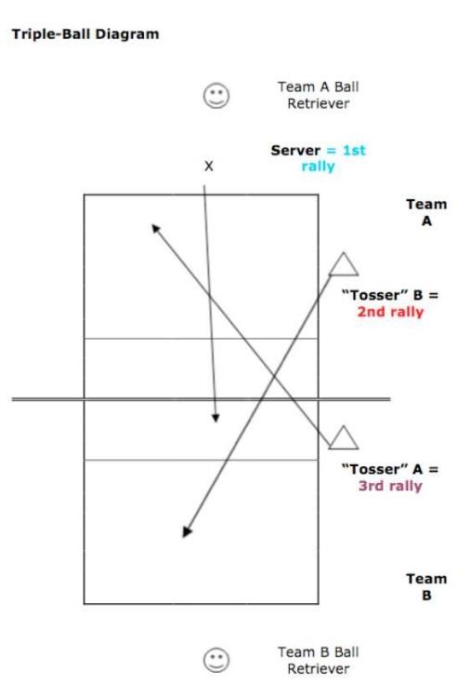

WEATHER

To check a game status:

Go to the league website for updated information.

SCORESHEET

Copies are available online at – www.gwacsports.com We do not track scores for this division. If you would like to track there are scoresheets online.

LINEUP SHEETS

Copies are available online at www.gwacsports.com. All eligible players’ numbers should be listed on the lineup sheet. The lineup sheets should reflect the players’ positions at the start of the game with the first server’s number circled. The lineup sheet is turned into scorekeeper before start of game and

LET SERVES

‘Let serves’ will be legal serves. A let serve is a ball that when served, hits the net without touching the net antenna and continues across the net into the opponent’s court.

FOUNDING MEMBERS of G.W.A.C. 1970
OUR LADY of VICTORY
OUR LADY of VISITATION
ST. ANTONINUS ST. CATHARINE ST. JUDE ST. MARTIN

CURRENT MEMBERS of G.W.A.C. 2023

OUR LADY of GRACE
OUR LADY of LOURDES
OUR LADY of VICTORY
OUR LADY of VISITATION
ST. ALOYSIUS - Bridgetown

ST. ANTONINUS

ST. BART
ST. BERNARD -Taylor Creek
ST. CATHARINE of SIENA
ST. CLEMENT
ST. DOMINIC
ST. IGNATIUS LOYOLA
ST. JAMES -White Oak
ST. JOHN - Dry Ridge
ST. JOHN the BAPTIST - Harrison

ST. JUDE

ST. LAWRENCE

ST. MARTIN of TOURS

ST. TERESA of AVILA

ST. WILLIAMS

AFFILIATE MEMBER
OAK HILLS YOUTH ASSOCIATION

GWAC WEB SITE www.gwacsports.com

Please visit the GWAC website which has schedules, standings, coaching tips and drills.

